

AIR POWER COMPANY
All Types of Oxygen Gas Plant,Nitrogen Gas Plant Dryer, Ammonia Cracker, Air Dryer, Compressor & Vacuum Pumps Electrical Panel, Capacitor Panel, Fire Control Panel Manufacturing, AMC Contractor, Seal & Service, Suppliers
GST NO :- O9BAZPK5978D2ZT
Office-Plot No-4, Block-9, Pocket-7, Sector-82, Noida, 201304.
Call at: M-09810241427 Office: +91 9953252100 Email:
airpowercompanynoida15@gmaiI.com, projectaepl@ymail.com, jaykishore828@gmail.com.

PROPOSAL

QTN/O2/50B/APC/26-27 /51 DATE : 05/05/2026

To, M/s

Reg: Oxygen Gas Generator — 30 NM3/hr. capacity - Offer.
We refer to the discussions you had with Mr regarding your requirement of an onsite
Oxygen gas generator for meeting urgent requirement for medical oxygen unit to supply oxygen to patients

We take pleasure in submitting you our Offer as under:

We are an engineering organization specializing in the design, manufacture and turnkey supply of
- On- site Gas Systems.
- Compressed Air Systems 'CAS'.
- Gas & Moisture Analyzers.
- Air / Gas Storage Tanks
- Portable Oxygen Analyser.
We have more than 10 years of experience in the subject & about 150 gas plant installations within and outside the country. We sincerely work towards increasing the overall reliability of ’On site gas plant’ technology by constantly working towards Improving designs, operating efficiencies, maintenance friendly design and layouts and by introducing new features.

First’s PSA Technique

’HPN’ series Oxygen gas generators
For penetration of 93% to 95% pure Oxygen from compressed air without employee de-oxo or purification units.

Pre commissioned Gas Plants
We offer pre commissioned gas plants which enables us supply fail proof machine Requiring no trials, experiments or wastage of resource at site. Every machine is pre piped, printed, tested and pre -commissioned.

Standby & built in PSA System new & highly recommended

Is a virtual standby PSA system, ready for use at the press of a button thereby Increasing the over-all reliability of the Oxygen gas plant at minimum cost and Space utilization. Furnace. We have many gas plants Operating with above feature.

Oxygen System -'OS'
A must for companies, requiring uninterrupted Oxygen gas on 24x7 basis for many years without a breakdown. The gas plant is a practical alternate to liquid Oxygen ’LIO’.

We have installed many such systems.

Oxygen Gas Plant — Features

- On site Oxygen generation from compressed air.
- Standby & built in PSA Oxygen system. new & recommended
- Online Oxygen Analyzer duly interlock with Gas Purity valve.
- Oxygen generation cost less than Rs.5/- per cubic meter.
- Flow Meter for 0 Line.
- Pre piped, cabled and a painted gas plant.
- Maintenance friendly, compact gas plant.
- Superior components for enhanced equipment performance over longer period of time.

Control Panel shall have following feature:
Oxygen Gas Plant Purity

As discussed, we are quoting to you for 95% pure oxygen gas.

Gas Plant - Capacity

We are offering a system, which shall make available PSA OxygenGas Plant. Flow of 20Nm3/hr,34Nm3,26Nm3 and Maximum Pressure 3.5Kg/cm2 Surge Tank.

Oxygen Gas Receiver
We are offering to manufacture /supply (water volume) Oxygen Gas storage tank to store 8,000 Ltr Oxygen at Minimum 3.5kg/cm2 and Maximum 4.00Kg/cm2 pressure. The tank shall Come with safety accessories and mountings.

Fully Automatic Gas Plant

We are offering to you a fully automatic gas plant. The gas plant shall keep
Switching on/off based on Buffer Tank Pressure Low O2 Plant Start and Tank Pressure High O2 Plant Stop.

Our Offer

Kindly find our offer as per following Annexure:
Annexure I Technical offer. Annexure II Commercial offer Thanking you and looking forward for your response.
Yours faithfully,

Equipment : ’ZMS 30OxygenGas Generator. Technical Specifications Alternate
Equipment : On site O2 Gas Plant
Model : 'ZMS Type
Capacity : 30 NM3/hr.
Basis of Gas Generation : Continuous
Plant Installation : Indoor

Product Gas Specification
Oxygen : 95%
Nitrogen and Gases : 3%
Dew Point :(-)40°c.
Oil : Nil
O2 plant generation pressure : 3.5 KG/cm2 Suction Pot : 3.5 to 4.0KG/cm2
Temperature : Ambient
Flow : 30 NM3/hr.

Screw Air Compressor Dryer & Filter

We have considered supplying a screw type, air cooled air compressor along with an air receiver of 3m³ capacity. The compressor shall be offered on optional basis. For efficient purification of compressed air, it's processed thru a compressed Air Treatment 'CAT’ unit.



Wet Air Receiver with Auto Drain Valve. Moisture Separator - Mechanical Type

Oil Filter - 1 st Stage


Oil Filter - IInd Stage type Air Dryer
After Filter

Dry air to 'ZMS’ Oxygen module & Storage Tank,
At the compressed air shall be pure and dry compressed air is subjected to the 'ZMS' Oxygen module. Good quality compressed air shall transform into consistent equipment working over a longer period of time.

PSA Oxygen Module ZMS
PSA Oxygen module consists of twin tower arrangement filled with activated Alumina & a special grade of Zeolite Molecular Sieves (Z.M.S.), which have Preferential adsorption for oxygen. While one tower remains under adsorption the Other undergoes regeneration / equalization automatically. For the purpose of quick Equalization, we have provided a reverse line equalization arrangement from Oxygen surge tank, which increase the operating efficiencies of the PSA Oxygen Module. At the Oxygen surge tank Oxygen gas of the above specifications shall be Made available, which is the product gas. Flow of product Oxygen gas is measured by installing a glass tube type rotameter.

Oxygen Gas Analyzer- On Line Percentage

We have considered to supply an online percentage oxygen analyzer in the product Oxygen gas line. This analyzer shall have 2 alarm relays (one for alarm and the Other for activating Vent Valve), one of the relay is interlocked with the 3rd port of a Vent valve, provided in the product Oxygen gas line in a fashion that the 3rd port Shall open to atmosphere in case the Oxygen purity from the plant drops below the Set limit. Line Diagram:

Oxygen Storage Vessel

We are offering a 8,000Ltr capacity product Oxygen gas storage tank, they shall store Oxygen at 3.5kg/cm2g. The storage tank shall have a high Pressure cut off switch, which shall provide trip command to the air compressor. Thereby unloading, Product Oxygen gas is made available from this particular Vessel and never directly from the gas plant.

Utilities Requirement
- Room Shade as for Drawing Your Scope
- Power Supply Cable as for O2 Plant Capacity Your Scope And Compressor 35mm2 Copper 3C Wire
- Earthing work and Electrical Panel Your Scope
- Base Frame for Gas Plant & Compressor Your Scope

Power SUPPLY MCCB 80 A
440 Volt AC, 3 Phase, 50 Hz
Connected Lead 30.0Kw
Consumed 0.6 kW per cubic meter Oxygen generated

Make for Oxygen Gas Generator .

- Screw Air Compressor Make-compair,moto,elgi
- Piping and valving. Optional Make-Jindal
- Wet Air Receiver-1000Ltr. Make-APC
- After Pre Filter with Auto Drain Valve Make-Concept
- Mechanical moisture separator with auto drain valve. Make-Concept

- Pre filters Auto Drain Valve. Make-Concept
- Activated Carbon stage heavy duty oil filter,ZMS. Make-UK
- Fine Filter. Make-APC
- Twin tower based ’ZMS’ Oxygen module Make-APC
- inter connected with set of Change over valves Make-Janatic.
- Air dryer as an integral part of the PSA unit. Make-IR
- First fill of activated alumina. Make-UK
- First fill of Zeolite Molecular Sieves (Z.M.S.). Make-UK
- Oxygen surge tank with safety accessories. Make-Janatic
- On line percentage oxygen gas analyzer. Make-Nucon,Virap
- Rotameter (Metal Tube). Make-APC

Electric control panel with following features:
- Fault Indicator &PLC.
- On line percentage oxygen analyzer.
- Instruments and controls as shown in the P & I diagram.
- Painting of the equipment.
- Commission of the equipment at site.
- Oxygen Gas storage tank of 8 cubic meter capacity Oxygen gas at 3.5kg/cm2g pressure complete with safety devices with orifice plate at outlet.

Space Requirement

We intend to install the proposed gas generator in linear fashion. Approx. space Requirement shall be as under:

Length (Left to Right) : 6.0Mtr.
Width (Front to Back) : 1.5Mtr.

Height (Bottom to Top) : 3.5 Mtr.
Installation : Indoor
- Approx.750mm maintenance spaces to be left on the left & right side and back Side of the installation.
- Approx.1000mm free space to be left in front of the gas plant installation.
- Oxygen Storage tank to be installed in the open.
- Space required for Oxygen Storage tank, not included in space indicated above.
- Civil work such as grouting level floor etc.. if required at site is not included
- Main Power connection to panel not considered it should be arranged by client

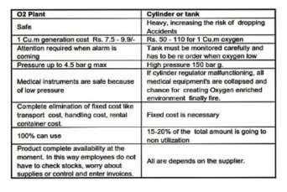

Annexure — II (Commercial offer & Bill of Materials) Client: M/s …………………………………...

Equipment: 'PSA Oxygen Gas Generator.

Model ’PSA Technology. Number of Qty
Capacity for Oxygen Plant | 30Nm3 | 26Nm3 | 20Nm3 | Qty.
1.0 Scrow Air Compressor  CFM-250/415VAC  S/D Stater with Auto ON/Off  Make-Ingersoll-rand,Mot | 30KW | 22KW | 22KW | 01 Set.
1.1 Air Dryer with Filter Pre Filter Element Fine Filter Element Oil Filter Element 1 & 2. Auto Drain Valve Make-APC,IR | 180cfm | 160cfm | 160cfm | 01 Set.
1.2 'ZMS' Oxygen Gas Generator Along with PSA Type unit  Model- PSA Module. Auto control Valuing  On line Oxygen Analyzer. Electrical Panel & Pressure Switch Surge Tank  Make-APC | 30Nm3 | 26Nm3 | 20Nm3 | 01 Set.

1.3 Oxygen Storage Tank Along with | 8m3 | 8m3 | 8m3 | 01 Set.
Operating Pressure3-4.00KG/cm2 Design Pressure-12Kg/cm2
Test Pressure-15 Kg/cm2 Design Temp-55degC
Safety Valve with Pressure Gauge Sheet Thickness-6mm X 8MM Make-APC
Total Amount:- Rs. | 24  Lac | 22Lac | 22Lac
Terms of Payment

- 40% advance along with the Purchase order.
- 55% Along with Proforma Invoice.
- 05% Agents Installation & Commissioning.

Terms & Conditions(Installation and Commissioning)

- Installation & Commissioning are included in given price Only Five Day.(only in India)
- Installation will be done within 05 days by our technical engineers.
- Accommodation charges of our engineers will be in your scope.
- If days extended more than 05 days, the engineer fare will charge 5000 per day.
- Number of Person 01 Engineer(Man Power Client Scope)

Delivery
Looking at your urgency, we shall offer delivery of the plant within 3 to 4 weeks Per Unit from the date of receipt of formal order along with the advance payment.

Taxes & Duties
Prices are ex works, Noida.
Packing & Loading - @ 3% excluding
GST-18%, excluding
Octroi, Insurance extra at actual or client’s scope. Freight will be excluding.
Erection & Commissioning Cost included in the prices offered.

Guarantee
We shall extend following guarantees
Equipment against poor work man ship/faulty performance for a period of 06 Months from the date of commissioning. ZMS Toping requirement for a period of 1years.
ZMS will be guaranteed for a period of 5 years though the expected life will be many more years.

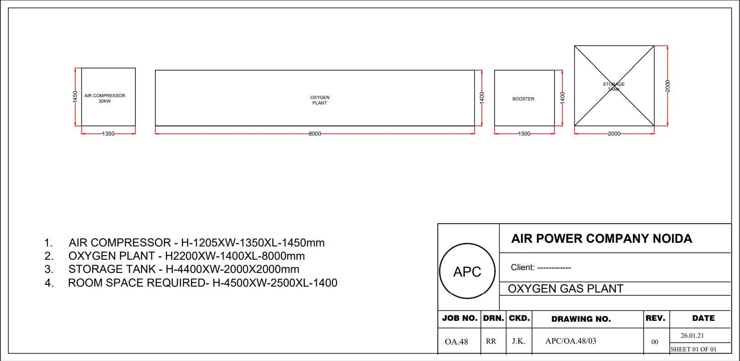

Work Address:

Air Power Company
Near Plot No-341

Udyog Kendra-I, Ecotech-III
G.B Nagar Noida 201 306. INDIA GST No : 09BAZPK5978D2ZT

E-mail : airpowercompanynoida15@gmail.com

